**DICOM and HL7**

**Dicom** is an international standard to transmit, store, retrieve, print, process and display medical imaging information. It includes a way to format the data and a network communications protocol. It contains more than just the image pixel data, but also a variety of attributes. These range from the modality the image was captured on to the patient medical record number and accession number.

**HL7** is a set of standards for the exchange, integration, sharing and retrieval of electronic health information. These standards ensure that the data is in the correct format so that it can be easily shared between systems in a seamless and integrated manner. The standard is broken down into 7 different categories:

1. Primary Standards
2. Foundational Standards
3. Clinical and Administrative Domains
4. HER Profiles
5. Implementation Guides
6. Rules and References
7. Education & Awareness

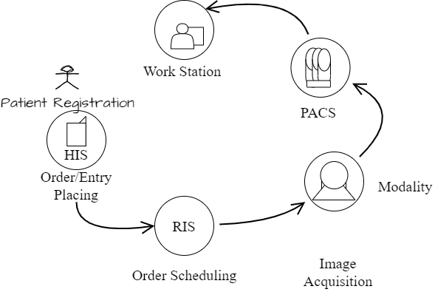

1. In the HIS (Hospital Information System), a hospital staff places an imaging study order for a patient. This order is then sent to the RIS (Radiology Information System), following the HL7 standard.
2. The order is then processed and scheduled in the RIS, where it will then be filled by a technician.
3. After the modality acquires the image, the image/data is then sent to the PAC (Picture Archiving and Communication System), following the DICOM standard.
4. The image is then sent to a radiologist’s workstation, following the DICOM standard. The radiology then generates a report and the result is communicated with the patient.

NB.

This is a very high level of the architecture but it mentions the most important aspects.

**BUILDING THE IMAGE VIEWER**

We are creating a viewer which displays three MRI images of the human brain in three planes (Sagittal View, Axial View and Coronal View).

* Sagittal view - A vertical plane passing through the standing body from front to back. The mid-sagittal, or median, plane splits the body into left and right halves.
* Axial view - A view obtained by rotating around the axis of the body, producing a transverse planar image, i.e., a section transverse to the axis.
* Coronal view - any vertical plane that divides the body into ventral and dorsal (belly and back) sections.

Brief description of the three planes from /faculty.washington.edu.

” The relative position and direction of brain structures are described with special words. For example, we can say that the frontal lobe is “rostral” to the occipital lobe. Because the brain is a three dimensional structure, any location in the brain can be localized on three planes – the x, y and z planes. The brain is can be cut on any of these planes and are named the coronal plane, the axial plane or the sagittal plane.”

**Let’s Begin Coding!**

**Requirements:**

React JS, Cornerstone JS,